**Exercise 1:**

In the example before you found the sine of 45° by first converting 45° to radians and then using the Dart sin function, which works in radians, to calculate the result. Now print the value of 1 over the square root of 2 in Dart. Confirm that it equals the sine of 45°.

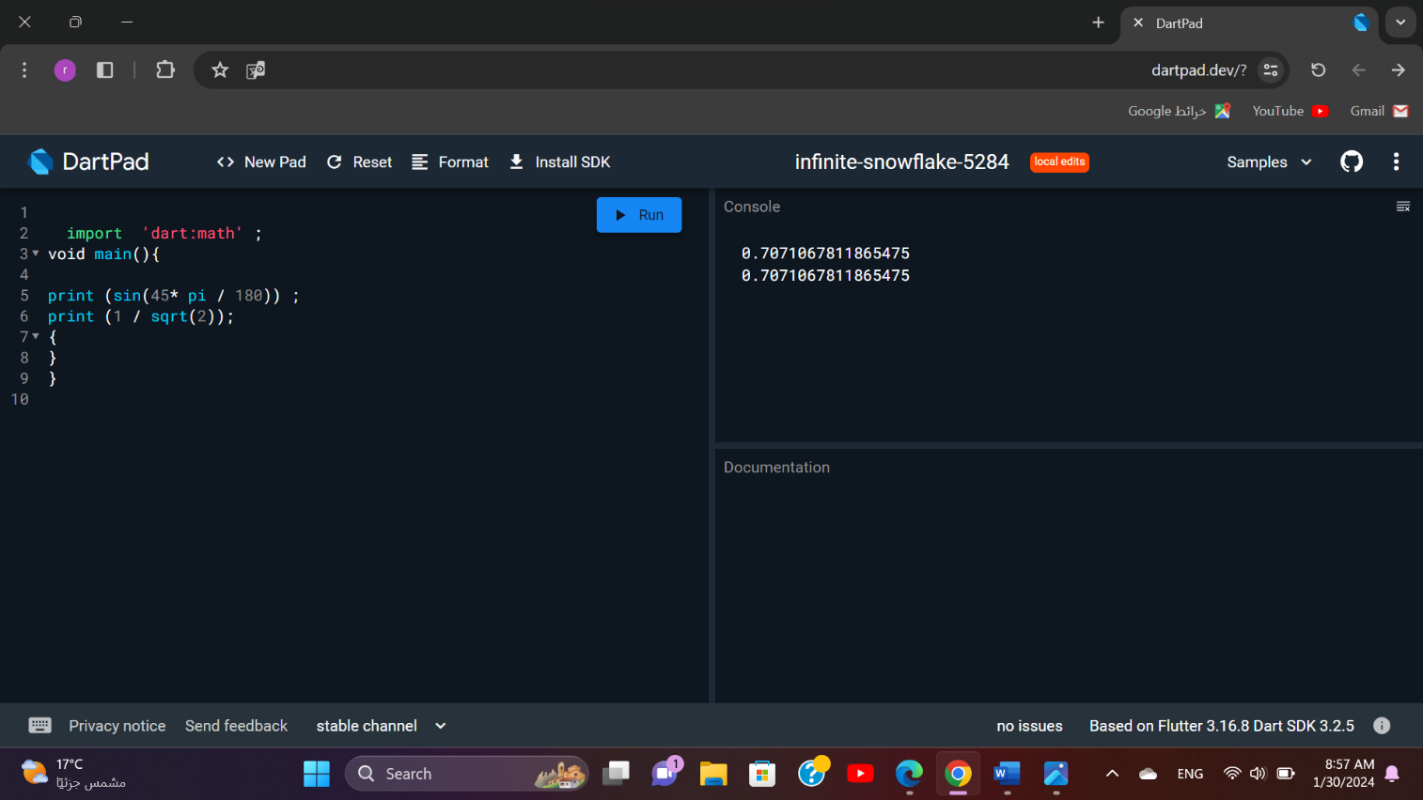

Yes is equals

E**xercise2**

1. Declare a constant of type int called myAge and set it to your age.

2. Declare a variable of type double called averageAge. Initially, set the variable to your own age. Then, set it to the average of your age and your friend’s age.

3. Create a constant called testNumber and initialize it with whatever integer you’d like. Next, create another constant called evenOdd and set it equal to testNumber modulo 2. Now change testNumber to various numbers. What do you notice about evenOdd?

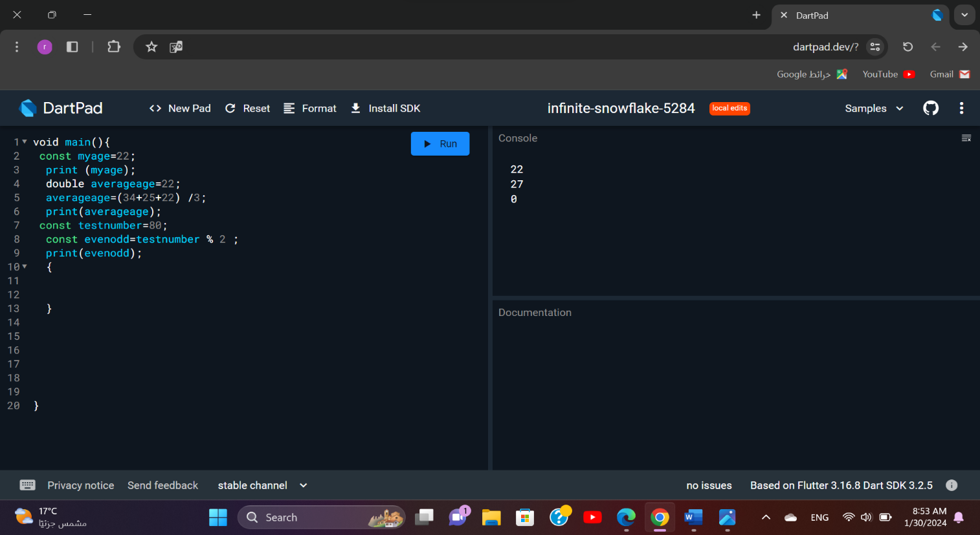

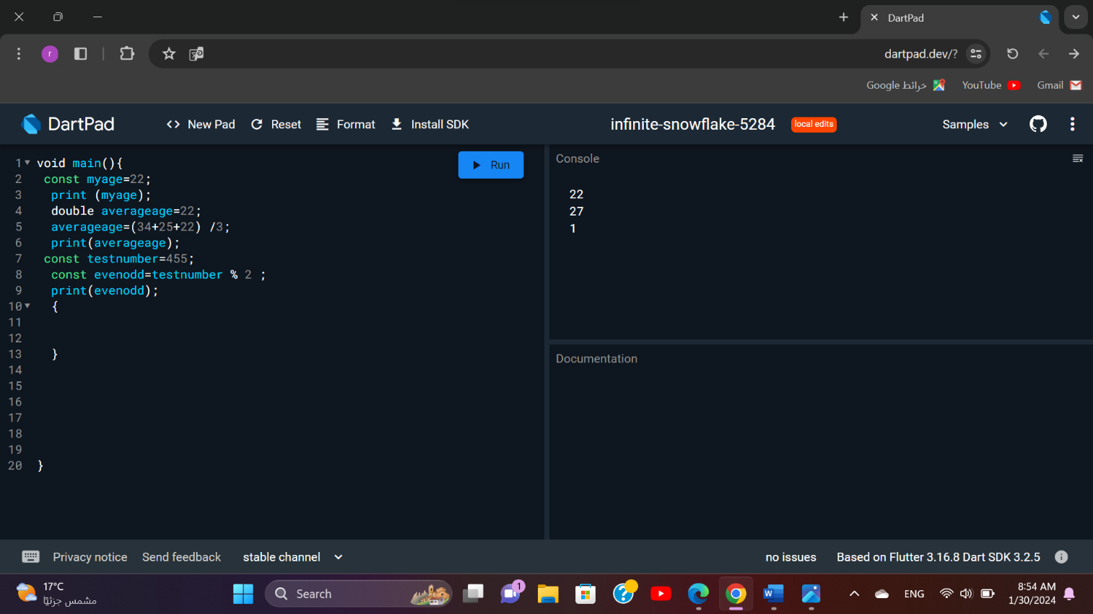

If the testnumber is odd the result = 1 if the testnumber is even the result = 0

**Exercise 3:**

Write a program to

1. Multiply two floating point variables and print the result. The values are 2.5 and 6.1

2. Calculate the square of the result from step 1 and print the result.

3. Increment the result from step 2 by 1 and decrement the result from step 1 by 1. Print both values.

4. Finally, swap the two values from step 3 and print the results. (e.g., put the first value in the second variable and vice versa)

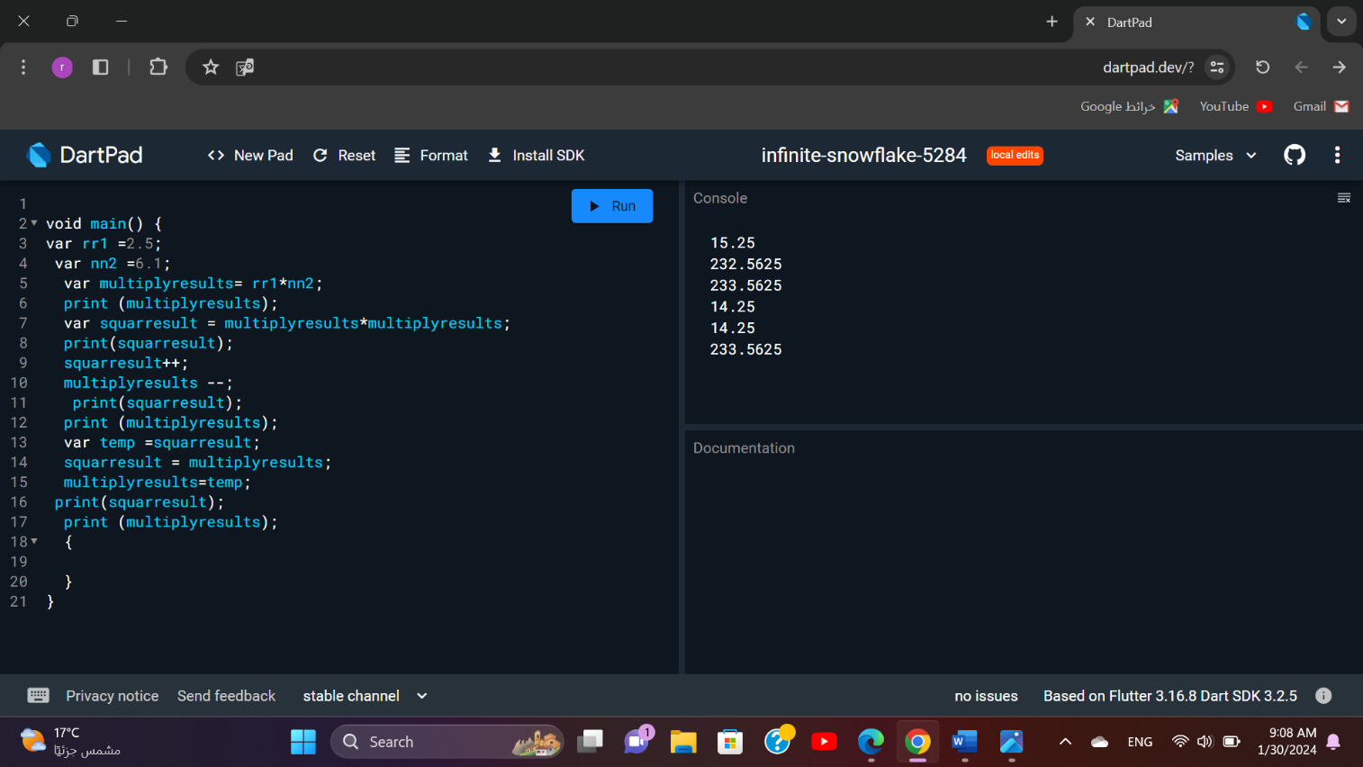

When we did a swap the values of squarresult and multiplyresults will be swapped

Between each other